The COVID-19 pandemic has dramatically changed how our schools operate and has illuminated the need to prioritize students’ safety, health, and well-being. I have been working with Kentucky SHAPE, the state health and physical education professional association to plan and prepare for the 2022-2023 academic year. We know that through the United States Department of Education Return to School Roadmap that prioritizing students’ physical, mental, and social-emotional health is a high priority reflected in two of the three landmarks.
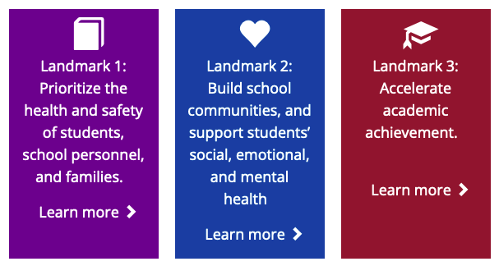
https://sites.ed.gov/roadmap/?utm_content&utm_medium=email&utm_name&utm_source=govdelivery&utm_term

To help with these priorities, Kentucky SHAPE is proud to be leading the national conversation with implementation of SHAPE America’s health.moves.minds. program. Health and physical educators are on the front lines of the social and emotional learning (SEL) movement, and this FREE curricular program equips our schools to do exactly that. In preparing for school reentry, incorporating SEL will be essential to best support our students. Both health and physical education instruction naturally reinforce and align with CASEL’s Core SEL Competencies by teaching students skills like teamwork, self-awareness, responsible decision-making, stress management, problem-solving, and goal-setting. These skills help support students’ health, well-being, and resilience, making health and physical education critical as we continue to navigate the lasting impacts of the COVID-19 pandemic.

Our schools also play a vital role in ensuring children and adolescents get the nationally recommended 60 minutes of physical activity each day. Compounding these concerns, low-income students, students with disabilities, and students of color historically lack access to safe places to play, physical activity equipment, and physical education instruction delivered by certified physical educators. It’s because of these realities that our schools must offer physical education and health education as part of a well-rounded education for all students.

Kentucky SHAPE has continued to support our profession and our communities with on-going virtual professional development aligned to SHAPE America and CDC considerations to help us meet the needs of our students. Focusing on the whole child through health and physical education instruction really is more important than ever for our students. It’s time to prioritize health & physical education. The well-being of our students depends on it.

